Makerspace 1 – Marketing Documents

- Media
  - Pamphlet
  - Powerpoint Slideshow
  - Video
  - Website
- Content
  - How does it meet our needs as a Campus?
  - How does it meet our needs as a Library?
    - Library Mission: “We foster learning and collaboration through our spaces, services, people, and resources”
    - Many students have no ability to “use their hands”. Let us help our students learn these skills.
    - Making things provides a wonderful opportunity for collaboration between the technical designers who make a thing work, and the artistic designers who make it beautiful.
  - Who does it serve?
  - What is a Makerspace?

Relevant content from UWEC goals:
A Place for Engaged Education
The signs that mark the paths through campus proclaim our strengths: high-impact learning experiences inside and outside the classroom that transform student lives and the world beyond our campus. By 2020 more than 95 percent of our students engage in at least two high-impact experiences during their time at UW-Eau Claire — and we are closing in on our 100 percent goal. In addition to growing numbers of students and faculty engaged in collaborative research and global immersion experiences, students are participating in internships, high-impact campus employment and civic engagement projects that expand skills and challenge students to test themselves by tackling real-world problems. UW-Eau Claire is the place for engaged education.
Aspirational Goal 2.1 - All students will connect and succeed
By 2020 provide all entering students (freshmen and transfer students) with the opportunity for a first-year experience as part of the LE Core that will actively engage them inside and outside of the classroom and lay the foundation for participation in high-impact practices.
Aspirational Goal 2.2 - All students will live what they study
Students come to UW-Eau Claire for learning that is rigorous, challenging, engaging and immersive. We aspire to surround each of our students with opportunities to live what they study inside and outside of the classroom and across the community. Students do so through collaborative research experiences, civic engagement and service-learning, immersion, internships and meaningful student employment — all high-impact practices that include intentional reflection to help students connect their experiences to their goals and to their responsibilities as active citizens of the world.
High Impact Experiences
- Undergraduate collaborative research, scholarship or creative activity.
- Civic engagement, including service-learning.
- International or domestic immersion.
- Internships, practicum or meaningful student employment.
(Does "Creative activity" apply to Makerspace projects? What complexity would be required?)

- Fabrication skills, creative mindset are where many small businesses are born.
- University students will benefit from being engaged in projects they enjoy.
- A sense of community will help with university retention.
- Being allowed to pursue one's interests will provide valuable extra-curricular experience.
- Affordable access for all audiences (students/faculty/staff)
- Fosters active learning and collaboration through hands-on creation and discovery
- A space to test ideas and experiment with …?

- Martin, The Promise of the Maker Movement for Education:
The Maker Movement is a new phenomenon, but it is built from familiar pieces, and its relevance to education has deep roots. It has long been argued that children and youth can learn by playing and building with interesting tools and materials (Montessori, 1912). Making and building can foster learning in a variety of ways that mesh with long-established theories of how learning unfolds. For example, testing ideas out in the world allows one to check expectations against reality, a process that can create conceptual disequilibrium, and can in turn lead to conceptual adaptation (Piaget, 1950). Physical creations can also create a context for social engagement around a shared endeavor. This can bring more- and less-experienced participants together around a common task—a configuration that often proves fruitful for learning (Lave & Wenger, 1991; Vygotsky, 1978).
- Quinn and Bell, “How Designing Making and Playing Relate to the Goals of K-12 science education” in Design, Make, Play: Growing the Next Generation of STEM Innovators:
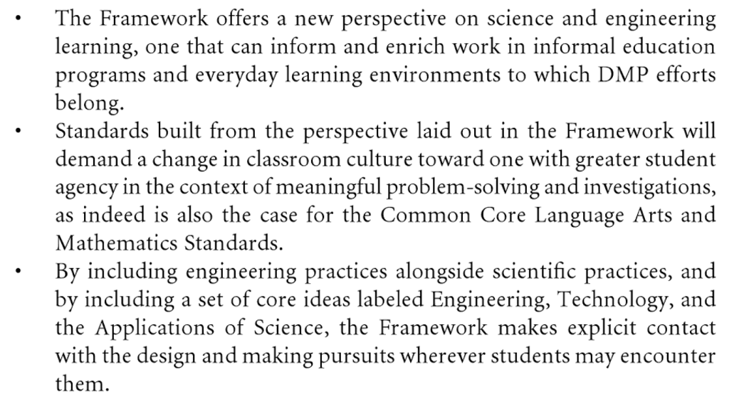
- Kalil and Miller, “Announcing the First White House Maker Faire” (https://obamawhitehouse.archives.gov/blog/2014/02/03/announcing-first-white-house-maker-faire)

By democratizing the tools and skills necessary to design and make just about anything, Maker Faires and similar events can inspire more people to become entrepreneurs and to pursue careers in design, advanced manufacturing, and the related fields of science, technology, engineering and mathematics (STEM).

Makerspace 2.a – Scopes and Tools

Scope
We hope the makerspace will seamlessly integrate into the curriculum and be applicable to a broad range a disciplines. Therefore, the proposed scope of the makerspace for the University of Wisconsin Eau Claire will be a combination of technical, media, and art design elements.

We envision the technical aspect of the makerspace to include tools such as a 3D printer, which could be used in computer sciences course for students to ____, but also by business students who could create a physical prototype for an entrepreneurial project. Art history students could explore replicating a sculpture, biology students could print models of organs such as the inner ear, and theatre students could print 3D props.

Equipment, Tools, and Supplies

Technical
- 3D Printer
  - 3D Printer
  - Mobile stand?
  - Materials: filament
- Electronics/Robotics
  - Soldering iron
  - Multimeters, Oscilloscope
  - Power Supply, Function Generator
  - Breadboards
  - Materials: proto boards, solder, components (resistors, capacitors, etc.), Arduino, Raspberry Pi
  - Lego Mindstorm
- Hand Tools
  - Hammer, Screwdrivers, Wrenches
  - Cutting tools
- Power Tools
  - Wired drill/driver, battery powered drill/driver
  - Dremel

Art Design
- Crafting/Art
  - Die cutter, cutting mat
  - Vinyl cutter
  - Button maker
  - T-shirt transfer press
  - Other: Glue, paper, paint, pencils, pens, wood, cardboard, easels, canvas
- Sewing
  - Sewing machines
  - Needles
  - Fabric
  - Fabric scissors
  - Cutting mat
  - Rotary cutter
  - Omnigrid Ruler
  - Thread
  - Pins
  - Iron
- Modelling
  - Putty, rubber, plaster, silicone, papier-mâché
  - Are there any reusable tools here?

Media
- Audio, photo, video, radio studio equipment
  - Computers with A/V editing software
  - Green/blue screen
  - Cameras
  - Lighting
  - Microphones
  - Mixers
  - MIDI keyboard
Other
- Creative Play
  - Legos

Which fields and tools (pottery/kiln, electronics/oscilloscope, painting/easels, bucket of Legos, etc.)
Percentage of Makerspaces that had:
-----------------------------------
3d printer: 34/45 = 76%
laser cutter: 20/45 = 44%
wood shop: 11/45 = 24%
metal shop: 15/45 = 33%
elec: 22/45 = 49%
textile: 4/45 = 9%
computer: 26/45 = 58%

Makerspace
------------
3-D Printer
3-D Scanner
Laser Cutter
Fabrics
Small-scale wood, metal, plastic
Electronics
Basic Arts (Crayons, Colored Pencils, Markers, etc)

Makerspace 2.b - Spaces

Open table space for making (Big enough to host a class?)
Audio Booth
Photography/video studio
Computer lab with specialized software/hardware (midi keyboards, mixers, etc.)
Storage closet
Meeting room

Suggested sizes:
11' x 26' Photo/Video studio
11' x 11' Audio studio
11' x 11' Media processing lab
22' x 22' Makerspace

Makerspace 2.c – Events

- 2D to 3D
  - Step by step demonstration of taking a 2 dimensional image and translating it to a 3D printer ready format.
- Copyright and you
  - A primer on intellectual property rights and what is legal when working with a 3D printer…
- After Dark Hole
  - Competitive annual challenge to student groups to design a hole for after dark, which the approved design will then be manufactured.
- Balsa wood bridge building competition
  - Everybody gets half a pound of balsa wood to build the strongest bridge they can. The strongest bridge wins.
- Appliance Autopsy - understand machines by taking them apart
- Paper airplanes and Origami
  - Fold paper into airplanes or Origami, duh!
- Eau Claire Maker Fair
  - Join with the public library and stout makerspaces to highlight member creations. Perhaps in Davies? Bring over any of our mobile tools.
- Blugold Beginnings / outreach to local highschools
- Recycle A Tshirt craft session
  - Learn how to cut and sew a T-shirt to turn it into a reusable tote bag
- Crockpot cooking class
  - A basic how to find a recipe, basic knife skills, how to use a crockpot etc.
- Holiday gift session(s)
  - Near finals, have programming that allows the students to make easy and giftable items
- Build a guitar effects pedal
  - Choose from existing circuit diagrams/kits for guitar pedals (phaser, flanger, chorus, reverb, distortion, etc.) and solder/assemble.
- Make a stuffed animal
  - Choose from our patterns or find your own. Cut out fabric, sew, and stuff an animal.
- Learn 3D design software
  - A lesson in how to use CAD and 3D modelling software
- Open Lab Time
- Orientation/Welcome to Makerspace
  - Tools, safety, culture, communication
- Knitting for Stress Relief
  - Knitting circle near finals week
- Podcast Skills
  - Editing audio with found content
- Getting in Touch with Arduino
  - Basics of Arduino
- Lean, Mean, Green Screen Machine Intro
- Making Across the Curriculum
  - faculty professional development workshop
- Learn to Solder
- Basic Sewing 101
- Design a Vinyl Sticker for Your Laptop
- Build and Print Your Own Voxel Character (http://voxelbuilder.com)
- Calc III Revolution (work with Math profs to build a surface of revolution gallery)
- RAs
- Bring your kids to work at the makerspace. For middle school and high school
  - Work on a project with your child.
- Relaxation station during finals.
- Hack your router: demonstrate how easy it is to crack older router passwords
- My first program: take group through introductory programming (possibly multiple courses)
- Web Programming (same as above)

Makerspace 2.d – Training
Which tools need certification? For example, you must be certified to use the 3D printer. But anyone can use the screwdrivers.

Makerspace 2.e – Name
- Dungeon of ingenuity
- Innovation station
- Chamber of creation
- McIntyre Makerspace
- Library Artistry and Building Space (LAB Space)
- Center for Learning, Artistry and Building (C-LAB)
- MakerLab
- HackerLab
- iLab (Ideation Laboratory)
- Launch Lab
- Blugold Makerspace
- FabLab
- MakeLab
- Innovation Sandbox
- Invention Studio
- Lab G (BG for Blugold)
- The Garage
- Toolbox
- Workbench
- Projectory

Considerations:
Short is best.
May best to not include ‘Maker’ in name as not everyone thinks of themselves as a ‘Maker’; identity barrier
Want to be clear that it is the whole university’s makerspace; also have to balance that it is in library, library clear supporter of it

Makerspace 3 – Evaluation
In order to evaluate the makerspace, we will need to track certain useful statistics. The following per-semester statistics will be tracked:
- Number of events held
- Number of attendees at events
- Website hits
- Number of new/completed projects which are related to a non-FYE class
- Number of new/completed projects which are related to an FYE class
- Number of new/completed projects which are not related to a class
- Number of professors who assign makerspace projects
- Number of new students who used the makerspace
- Number of students who used the makerspace
- Makerspace-related equipment checkouts
- Questions answered
- Hours worked by student employees
- Hours worked by staff
- Expenditures for Materials, Equipment, Maintenance
In addition, we would like to maintain a method for feedback from students and faculty.

